Reiki  LEVEL 1 TRAININGS  For People with Disabilities |  |  |  | Reiki brings us on a journey, a path of healing.  By giving a gentle touch, we activate our  heart’s center in healthy ways that encourage  our bodies towards wellbeing.
Laurie and Val are Master Level practitioners with backgrounds in Wu Wei Reiki. Both believe in the importance of offering modalities such as Reiki to provide a quiet state in a chaotic and stressful world. Our Reiki trainings are meant to enhance one’s ability to stay connected and present with oneself whether at work or at home.
Our trainings consist of 4 to 6 people, affording each person the individual attention one deserves.
Trainings are held on 2 consecutive days with an additional day for practice. Cost: $200
 | DATES  December 7, 8, and 14, 2019  Saturday the 7th 10:30-2:30  Sunday the 8th 9:30-12:30  Saturday the 14th 10:30-1:30 |  |  | IN THIS TRAINING  • Receive four attunements  • Learn the history of Reiki  • Experience hands on practice  • Deepen your skills by offering Reiki  to yourself and others.
 | LOCATION |  |  | CONTACT
 | Ed Roberts Campus  Fitness Studio |  |  | Valerie Jew  Laurie Famera | valeriekyee@gmail.com  lauriefamera@gmail.com

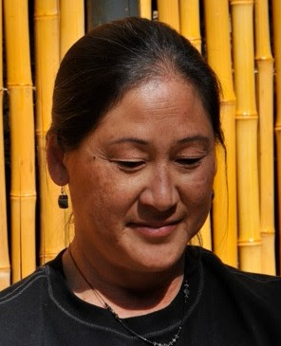 | Valerie Jew retired after 27 years of teaching, first with deaf and hard of hearing students  and second as an IT specialist and computer teacher. She devotes her time to community-based projects related to health and wellness around the Bay Area. She teaches restorative  and integrative yoga classes in the Oakland Public Schools, Ed Roberts Campus, Nest Yoga,  Alta Bates Summit Hospital on the Acute Rehab floor. By drawing one’s attention to pacing, language and repetition a person notices a difference in their mental, emotional and physical body.
 | Laurie Famera embraces the notion that in order to care for others and maintain balance in our own lives, we need to begin with self-care. She believes in providing an opportunity where all individuals move in the direction of improving their quality of life, at their own pace. As an Urban Zen Integrative Therapist, Advanced Relax and Renew Trainer, and Reiki Master practitioner she combines these modalities to provide a calm and nurturing environment as a means of reducing stress and to support the healing process. After many years of working in public high schools and the corporate world, she understands the importance of meeting an individual’s needs at their own comfort level. In addition to her private practice, she currently teaches Gentle Yoga at Marin JCC.

